ideation phase
Define the Problem Statements

Date | 5 November 2025
Team ID | NM2025TMID00401
Project Name | Garage management system
Maximum Marks | 2 Mark

Customer Problem Statement Template

To design and develop a Garage Management System (GMS) that integrates with Salesforce CRM to streamline garage operations — from customer management and service scheduling to inventory, billing, and analytics.

The system should leverage Salesforce’s capabilities (like Service Cloud, Sales Cloud, and Automation tools) to improve customer experience, operational efficiency, and business insights.

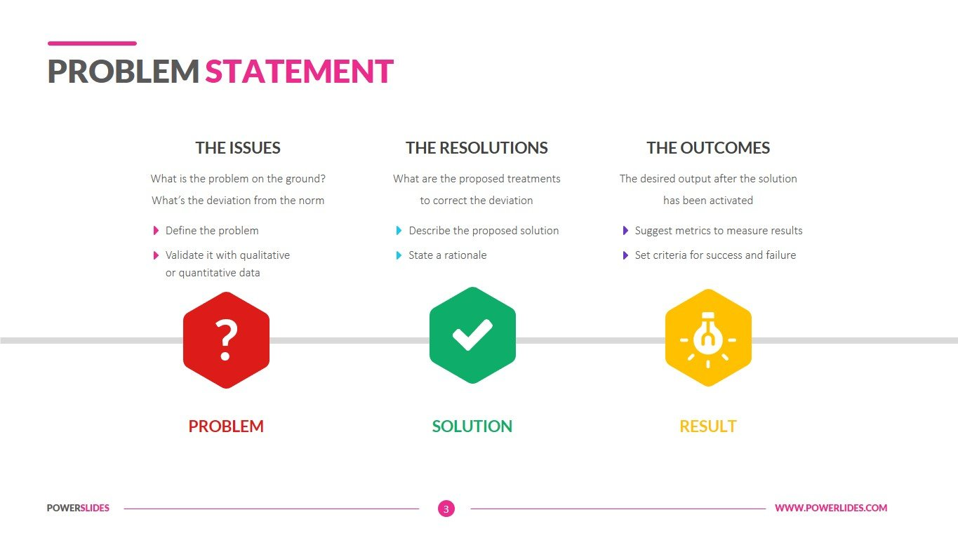
Problem Statement (PS) | iam (Customer) | I’m trying to | but | Because | Which makes me feel
PS-1 | a Garage Admin | assign a mechanic to a customer’s service job | the system doesn’t show mechanic availability or workload | the system doesn’t show mechanic availability or workload | the system doesn’t show mechanic availability or workload
PS-2 | a Service Advisor | create a new service appointment for a customer | I can’t access the customer’s past service history easily | data is scattered across different spreadsheets and tools | annoyed and unprepared when talking to the customer

Problem Statement 1:
Garage administrators face challenges in efficiently assigning mechanics to service jobs because the system does not provide visibility into each mechanic’s availability or workload. The lack of integration between job scheduling and staff management leads to confusion, overlapping assignments, and operational inefficiency. This makes administrators feel frustrated and unable to effectively manage daily operations.
Problem Statement 2:
Service advisors struggle to create service appointments smoothly as they cannot easily access a customer’s past service records or vehicle history. Since customer data is scattered across multiple tools or spreadsheets instead of being centralized within Salesforce, it becomes difficult to provide personalized service or accurate recommendations. This situation leaves advisors feeling unprepared and dissatisfied when dealing with customers.

